Modelling of Porous Aluminium using Molecular Dynamics Simulations

Aya Ragab

Hussein Dirawi

Sahaj Jain

Abstract

The aim of this project is to model porous aluminium through Molecular Dynamics simulations and discuss the variation of density with different simulation parameters such as temperature, atomic potentials, and number of timesteps. Results show that the density and structure can be controlled by varying the number of timesteps.

**1 Introduction**

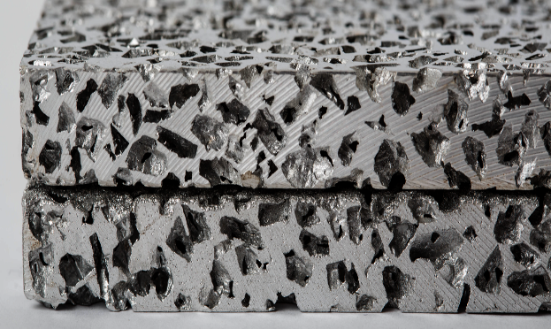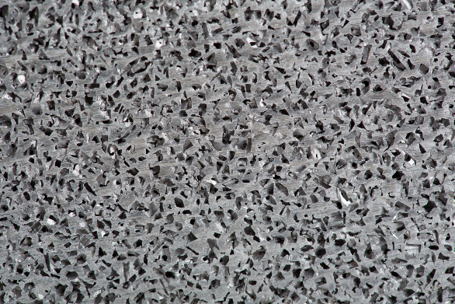Aluminium foam consists of up to 95% of its volume as voids in two different kinds of structures. These two classifications depend on the density, appearance, shape of the cavities, and manufacturing methods. The pores can be created by either physical or chemical means.

Figure 1: Porous Aluminium (Source: alumeco.com)

Porous aluminium (also known as aluminium foam) is a novel way of using aluminium as a material. It is characterized by its durability and lightweightedness. The presence of interconnected pores results in a high surface area to volume ratio and high specific stiffness, while inheriting the properties of strength, electrical and thermal conductivity, and anti-corrosivity from the base metal.

On extensive literature review, a gap was noticed in the simulation of porous aluminium starting from the crystalline structure. In this report, efforts have been made to fill this gap in research by attempting to simulate porous aluminium while understanding the influence of the amorphous phase on the result.

**2 Methodology**

Molecular Dynamics (MD) model of an FCC aluminium crystal with 108000 atoms using Lennard-Jones (LJ) potential is created based on [1]. The values of ɛ = 0.3920 (depth of the potential well), σ = 2.62 (distance at which the particle-particle potential energy is zero), and atomic mass of 26.982 g/mol are also taken from [1]. All the simulations use periodic boundary conditions, and an LJ potential cut-off radius of 2.5 σ. The timestep is taken as .001 ps due to the highly dynamic process.

All simulations in this project are carried out using LAMMPS [2] and are run on RWTH’s HPC cluster. OVITO [3] is used for visualization of the results.

**Simulation:**

* Lattice Structure:

Crystal of aluminium with FCC structure and lattice constant of 4.05 A is created. The density of crystalline aluminium is output as 2.698 g/cm3.

Figure 2: Lattice Structure of FCC Aluminium

* Step 1: Equilibration at 300 K:

The atoms of the FCC structure are given a velocity of 300 K with a Gaussian distribution. The NPT ensemble is run at 300 K for 10000 timesteps. The NPT ensemble is used to bring the atoms to the desired temperature of 300 K.

* Step 2: Glass Transition of Aluminium:

The glass transition temperature of aluminium is between 600 K and 700 K [4]. The NPT ensemble is used to increase the temperature to 700 K in order break the FCC crystalline structure and convert it to a non-crystalline form.

Figure 3: Glass Transition (Step 2)

* Binding:

To facilitate clustering of the atoms, the ɛ value is changed to ɛ10x = 3.920 and the cut-off radius is changed to 10 σ.

* Step 3: NVE Interaction:

Using the NVE ensemble, the atoms are allowed to interact with each other for 10000 timesteps. The increase of ɛ to ɛ10x results in a temperature of the system to rise exponentially. Therefore, the velocities of atoms are rescaled using *temp/rescale* every 0.1 ps to match the temperature of 700 K. Clustering of atoms is noticed at the end of this step.

Figure 4: NVE Interaction (Step 3)

* Step 4: Temperature Reduction:

The temperature of the structure is reduced in a stepwise manner from 700 K to 600 K  
(step 4a), from 600 K to 400 K (step 4b) and then from 400 K to 300 K (step 4c).

Figure 5: Temperature Reduction (Step 4)

*Step 4a: 700 K to 600 K  
ρ = 0.259 g/cm3*

*Step 4c: 400 K to 300 K  
ρ = 0.509 g/cm3*

*Step 4b: 600 K to 400 K  
ρ = 0.328 g/cm3*

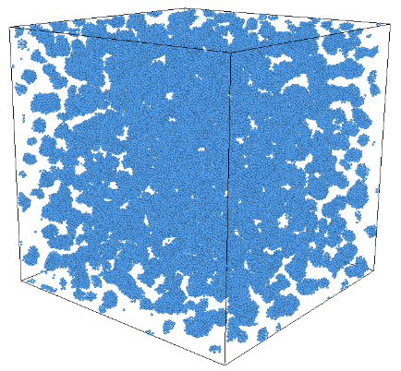

* Step 5: Equilibration:

The equilibration is carried out using the NVE ensemble at 300 K along with *temp/rescale*. The main goal of the equilibration step is to conserve the total energy while allowing the atoms to move freely [6].

* Step 6: Energy Minimization:

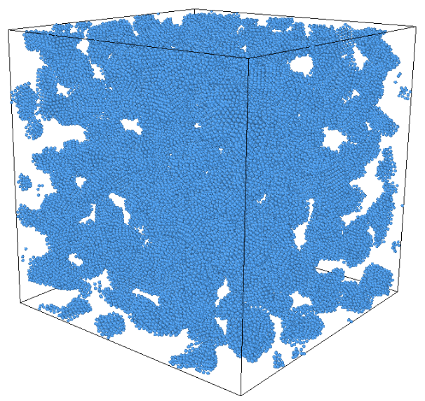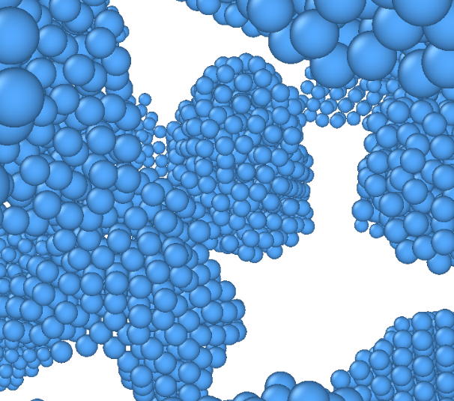To locate the local minima of the atoms by iteratively adjusting their coordinates, the conjugate gradient (CG) algorithm is used for the energy minimization. The basic criterion of the energy minimization is ‘stopping tolerance for energy (*etol*)’.

Figure 6: Energy Minimization (Step 6)

**3 Results and Discussions**

The main purpose of this project is to model porous aluminium starting from crystalline aluminium. It is noticed that varying the glass transition temperature to values between 700 K and 900 K does not influence the final structure of aluminium as much as expected. However, it is noticed that the number of timesteps while reducing temperatures is an important parameter in determining the structure and porosity of the final model. Plot 1 illustrates the change in density vs temperature with varying timesteps.

Plot 1: Density vs Temperature with varying Timesteps

Through the simulation, the structure of aluminium changes from the crystalline FCC structure to a structure where the atoms form clusters. These clusters can be assumed to be the amorphous state of aluminium, the structure of which is analogous to that of a frozen liquid.

It is further seen that the resulting structure changes from an amorphous-like form to a porous-like form with the increase in number of timesteps in the temperature reduction process.  
At timestep equal to 15000, the final density at 300 K is virtually the same as that of crystalline aluminium. This was the upper limit of our comparative study.

As a scope for further research, the simulation could be run with the Embedded Atom Model (EAM) potential and the results could be compared.

**4 Conclusions**

MD simulation of porous aluminium is carried to understand the behaviors of aluminium as it is heated to its glass transition temperature and then the temperature gradually reduced. The results show a high dependency of the density (and therefore porosity) on the number of timesteps in the temperature reduction process.

Although the glass transition temperature of a material is an important factor in the transition of the structure from an amorphous state to a viscous state, and vice versa, their influence in molecular dynamics simulation using LJ-potential is still a point of discussion and further research.

**5 References**

[1] Aluminium nanofoam under tension: Influence of porosity - Gasper Krivic, Sandeep Patil, March, 2021.

[2] LAMMPS stable release 29 October 2020 - Steve Plimpton, Axel Kohlmeyer, Aidan Thompson, Stan Moore, and Richard Berger.

[3] Visualization and analysis of atomistic simulation data with OVITO - the Open Visualization Tool. Modelling and simulation in materials science and sngineering, 18(1):015012, December 2009 - Alexander Stukowski.

# [4] The behavior of stress correlations and glass transition temperature in liquid aluminum at cooling and heating process by E M Kirova and V V Pisarev.

# [5] Glass transition of aluminum melt. Molecular dynamics study by L.N. Kolotova, G.E. Norman, and V.V. Pisarev. Journal of Non-Crystalline Solids 429 (2015) 98–103.

[6] [Molecular mechanics and multiscale modelling of materials](https://moodle.rwth-aachen.de/course/view.php?id=17578), RWTH - course notes.